The Real Easter Egg – a bulk order
The Real Easter Egg Company is again offering several choices of fair-trade Easter eggs this year, each of which marks Easter in a special way. A Christian company, they believe in saying that Easter isn’t just a time for buying chocolate, it’s a reason to stop and think about why we have Easter (and Easter eggs) at all.
By buying in bulk, we will avoid the postage associated with individual purchases – these eggs are not going to be available in supermarkets – and you have until early March to place your order through the Justice & Peace group at Our Lady’s.
The choices are
- The Dark Chocolate egg, with a 24-page Easter story-activity book, a prize competition and a 150gm smooth super-thick dark chocolate egg – at £5.50
- a milk chocolate “Original” egg with a 24-page Easter story-activity book, a prize competition and a 150gm milk chocolate egg – at £4.50
- The Special Edition has a simple guide to Easter, a designer Easter card, an Easter blessing milk chocolate bar (80gm) and a luxury milk chocolate egg (200gm) – at £9.99
- a Sharing Box containing 30 Belgian chocolate midi eggs (20gm each) and 30 Easter story activity posters – at £30.00
- a Fun Pack containing 6 milk chocolate midi eggs (20gm each) and an Easter story activity poster – at £5.00
- Easter Blessings bars featuring “The Resurrection” image by award-winning artist Martina Peluso – 80gm fair-trade milk chocolate – at £3.00
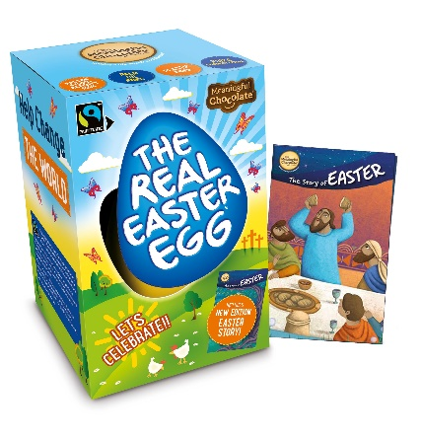
As well as being made from fair-trade ingredients, all are palm-oil free and plastic free, consistent with the company’s concern for the environment.
Order via the Justice Peace group – Andy Bebington will be placing a bulk order on 5 March and will happily arrange delivery of your order when it comes in.
Cash with order, please, either by cheque (payable to A Bebington) to 79 Shirley Way, Shirley CR0 8PL or credit AP & ME Bebington at 56-00-46 account 01038893. Please detail exactly what you want and give your address and phone number so that we can deliver your order in due course. If you have any queries, or want to confirm your order, Andy is at andy.bebington@gmail.com

